COVID Drivers
Did Aggressive Driving Behaviors Increase After COVID?
Lisa Over
2026
Table of Contents
Section 1: Business Understanding 4
1.1 Background 4
Organizational/Context Description 4
Domain and Context Assessment 4
Problem Situation 4
Data Science Justification 5
Stakeholder Identification 5
1.2 Project Objectives and Success Criteria 5
Primary Objective 5
Secondary Objectives 5
Quantitative Success Criteria 6
Qualitative Success Criteria 6
Impact Assessment 6
Timeline and Milestones 6
1.3 Assessment of Responsibility 6
Legal and Regulatory Considerations 6
Privacy and Data Protection 7
Bias and Fairness Concerns 7
Stakeholder Impact Analysis 7
Mitigation Strategies 7
1.4 Data Science Goals and Success Criteria 8
Technical Problem Framing 8
Data Science Objectives 8
Technical Success Criteria 8
Analytical Approach Overview 9
Objective Technical Mapping 9
Constraints and Assumptions 9
1.5 Project Plan 9
Phase-specific Planning 9
Timeline and Milestones 10
Risk Identification and Contingencies 10
Section 2: Data Understanding 10
2.1 Data Inventory 10
Data Collection Methodology 11
2.2 Data Description 11
Comprehensive Data Dictionary 11
Data Structure and Relationships 11
Temporal Coverage and Granularity 12
Data Volume and Scale 12
Categorical Variable Encoding 12
2.3 Data Exploration 13
Univariate Analysis 13
Bivariate Relationships with Temporal Patterns and Trends 14
Hypothesis Generation 18
2.4 Data Quality Assessment 18
Completeness Analysis 19
Accuracy Assessment 19
Consistency Evaluation 20
Timelines and Currency 20
Relevance and Coverage 20
Data Quality and Impact Assessment 20
Appendix A: Data Dictionary for CRASH 21
Appendix B: Data Dictionary for FLAGS 23
Appendix C: Coded crash Variable Fields 27
Appendix D: Enumeration of Counties 28
Appendix E: File Information 30
Appendix F: Columns and Data Types 35
AI Statement of Use 45
Bibliography 45

Section 1: Business Understanding

1.1 Background

Organizational/Context Description
PA Data Discourse (PDD) is a new digital news publication focused on investigative public interest reporting. PDD collects and analyzes open data from state, county, and municipal portals to provide data-driven insights on topics of interest to Pennsylvania residents.

Domain and Context Assessment
A current topic of interest that has open questions involves PA drivers and driving behaviors that may have changed during and after the COVID-19 pandemic. A majority of Americans believe drivers have been more aggressive since the lockdown.
A Pew Research Center (Leppert, 2024, November 12) report published in November 2024 reveals that a majority of Americans believe more drivers have been distracted, aggressive, and/or under the influence of drugs or alcohol since the pandemic. As many as 78% of Americans say more people are distracted by their cell phones, 63% say more people are driving too fast, 63% say more people are driving aggressively (weaving, tailgating, or running red lights), and 51% say more people are driving while under the influence of alcohol.
A National Safety Council (NSC, 2020, July 21) report published in the summer of 2020 shows that although there were far fewer cars on the road during the pandemic, the fatality rate per miles driven rose by 23.5% during the quarantine in May 2020 compared to the same month the previous year. PennLive reporter Jordan Wolman interviewed the manager of statistics for the NSC, Ken Kolosh, who explained that there was “one death for every 84 million miles driven in May 2019, but one death for every 68 million miles driven in May 2020.” (Wolman, 2020, July 30) The Pennsylvania Capitol-Star (Henderson, 2023, November 13) reported a 12% rise in traffic fatalities in Pennsylvania from 2019 to 2022 despite fewer cars on the roads in the state.
The Foundation for Traffic Safety (FTS) of the American Automobile Association (AAA) (Tefft et al., 2022) conducted a Traffic Safety Culture Index survey in 2020 where respondents reported the amount of time they have spent driving during the first few months of the pandemic and if they engage in risky driving behaviors, such as texting, speeding, drinking, and running red lights. The results of this study show that drivers who engage in risky behaviors increased the amount of time they spent driving while safer drivers decreased the amount of time they spent driving. Another FTS study (Tefft et al., 2021) involved a New American Driving Survey where respondents reported their travel from the previous day. The goal of the study was to quantify the reduction in the amount of driving during the pandemic, and the results showed that the number of trips taken by U.S. residents dropped abruptly in April 2020. Compared to the average number of daily trips from July through December in 2019, the average number of daily trips dropped by 40% in April 2020.

Problem Situation
The studies outlined above confirm the following statements about driving habits in the United States during and after the pandemic:
- Americans believe aggressive driving has increased since the COVID-19 pandemic, and super majorities believe that one or more of the following specific behaviors have increased: distracted driving, driving too fast, and reckless driving including weaving, tailgating, and running red lights. (Leppert, 2024, November 12)
- Fatalities per miles driven in May 2020 increased significantly over the same month in 2019. (NSC, 2020, July 21)
- Americans who admit to engaging in risky driving behaviors increased the amount of time they spent driving while safer drivers reduced the amount of time they spent driving during the first few months of the pandemic. (Tefft et al., 2022)
- The average number of daily trips taken by car dropped significantly in April 2020 during the COVID-19 lockdown compared to the last six months of 2019. (Tefft et al., 2021)

Data Science Justification
While these studies confirm important trends and patterns, none of them show if aggressive driving actually increased during COVID or if it has since declined or stabilized. They also do not show if the rate of accidents caused by at least one aggressive driver has changed or if any type of aggression (speeding, distraction, recklessness) has increased more than others. Data scientists can answer these questions using appropriate data and modeling techniques.
It is important for the public to know if they are correct about an increase in aggressive driving, and it is important to understand which types may have increased. Public awareness brings solutions by moving the public to elect public officials who will enact laws or by moving organizations and individuals to organize and fund advocacy or education efforts.

Stakeholder Identification
The primary stakeholders in this research are the editor and the public. The editor determines if the content is accurate and meets editorial standards, if the methodology is sound, and if the article is compelling and fits within the mission of the publication. The residents of Pennsylvania are concerned about aggressive driving and want to know if their perceptions are correct. This project will answer this question to promote meaningful dialog about driving behavior.
The secondary stakeholders are public officials, groups, and organizations who will be moved by the public to facilitate change through policy, laws, advocacy, and education.

1.2 Project Objectives and Success Criteria

Primary Objective
Determine whether there has been a statistically significant increase in aggressive driving since the COVID-19 pandemic to provide evidence-based conclusions for PA Data Discourse readers about driving risks within 12 weeks.

Secondary Objectives
- Identify specific aggressive driving behaviors that increased during COVID-19.
- Identify co-factors for crashes involving aggressive driving, such as age, day of week, geography, terrain, or atmospheric conditions.
- Develop accessible visualizations for public understanding.
- Create reproducible methodology for ongoing aggressive driving related crash monitoring.

Quantitative Success Criteria
To ensure technical rigor, this project will assess the performance of two change point detection (CBD) algorithms. The performance of each algorithm will be assessed using performance measures, statistical significance thresholds, and confidence intervals that are appropriate for detecting change points given the characteristics of the data and the algorithm.

Qualitative Success Criteria
- Editorial confidence in methodology
- Reader engagement demonstrates understanding
- Public servants, including elected officials and law enforcement, reference the findings
- Methodology adopted by other researchers
The findings will be reviewed by peers and editorial staff before publication. Community engagement will be encouraged and monitored for feedback.

Impact Assessment
- Evidence informing driving decisions for 13+ million residents of Pennsylvania
- Foundation for policy, advocacy, and education effecting the entire commonwealth
- Establishes PA Data Discourse’s data journalism credibility
- Creates lasting aggressive driving monitoring capability

Timeline and Milestones
Weeks 1-4 Data integration and assessment
Weeks 5-8 Statistical analysis and model results
Week 9 Draft of paper and report complete
Week 10 Peer review and refinement
Weeks 11 Final production
Week 12 Final publication
Week 13+ Impact monitoring

1.3 Assessment of Responsibility

Legal and Regulatory Considerations
The Pennsylvania Department of Transportation (PennDOT) maintains comprehensive crash data covering all reportable traffic incidents throughout the commonwealth. Data for this project were obtained from the public download section (PennDOT Crash Data Download, n.d.) of the Pennsylvania Crash Information Tool (Pennsylvania Crash Information Tool, n.d.). No regulations, terms of use, or licensing information is specified for using data from this source. Nevertheless, the principles from the CLeAR Documentation Framework for AI Transparency (Chmielinski et al., 2024, May) and Data Feminism (D’Ignazio and Klein, 2020) will be adopted to ensure responsible data science practices are implemented throughout this project.
This project adheres to the CLeAR Documentation Framework for AI Transparency as follows:
- Comparable: The CRISP-DM Framework is a data mining methodology that provides a structured approach for transforming business problems into data driven solutions and specifies clear documentation guidelines throughout the project life cycle. This project follows CRISP-DM and can be compared to any other project that follows CRISP-DM.
- Legible: Documentation for this project includes the components specified in the CRISP-DM Framework that will be reviewed by editorial staff and an article for a general public audience. Both audiences consist of non-technical readers. The documentation and article will be written to these audiences.
- Actionable: The article will provide information and a platform for discussing the results.
- Robust: The plan for this project is to continue incorporating data as it becomes available so stakeholders can see if the trends change over time or in response to new policies, laws, advocacy, and education.
Principles from Data Feminism that will influence this project include justice, oppression, equity, co-liberation, reflexivity, and understanding history, culture, and context. (D’Ignazio and Klein, 2020, p. 60)

Privacy and Data Protection
Although the crash data are anonymized, an analysis of the geographic location of crashes could stigmatize certain communities or neighborhoods, and this will affect the primary stakeholders if they live in an area where the aggressive driving rate is high.

Bias and Fairness Concerns
It is possible that the available data are biased because of implicit biases held by law enforcement and/or witnesses. Events are interpreted and information is recorded by fallible human beings.

Stakeholder Impact Analysis
It is imperative to be mindful of the fact that each record in the crash dataset represents one or more people who witnessed or experienced an event that was an inconvenience at its best and traumatic or fatal at its worst. This work will promote traffic safety and is not a venue for sensationalizing dangerous driving behaviors.

Mitigation Strategies
The data scientist recognizes her position of privilege and power, and acknowledges that data are not objective and that avoiding bias requires reflection, listening, understanding, and thoughtful engagement. The focus of this project is on behavioral patterns around traffic safety. The goal is to answer specific questions related to a change in overall behavior. It may be useful to aggregate by county or urban/rural areas but not to specific municipalities or neighborhoods or by socioeconomic factors. Findings will be presented with clarity and appropriate context to avoid misinterpretation.

1.4 Data Science Goals and Success Criteria

Technical Problem Framing
Crash data are collected and timestamped based on the date of the crash. The level of granularity of the public dataset is by month and year. This allows for visualizing the data over time to show any abrupt changes in the data and for applying machine learning techniques for detecting if an abrupt change is statistically significant. The techniques chosen for this project include both supervised and unsupervised learning algorithms. For supervised learning, each record will be coded manually as being before or after COVID-19. For unsupervised learning, the algorithm will find any abrupt change points without this manual coding.
According to Aminikhanghahi and Cook (2017), change point analysis is appropriate for analyzing human activity. Although the example they provide is related to sensor data from mobile devices, the goal of this project is to identify changes in human behavior using data that were collected manually by law enforcement. This project aims to identify if a change point exists between crashes that occurred before COVID-19 and those that occurred after where the property of aggressive driving changed, specifically, that aggressive driving increased. NHTSA (n.d.) defines aggressive driving as follows:
...violations that encroach on others’ safe space, such as driving much faster than prevailing speeds, following too closely, making unsafe lane changes, and running red lights, either on one occasion or over a period of time, may indicate a pattern of aggressive driving. (para. 1)
This project uses variables related to these behaviors in addition to variables related to anything that existed prior to the crash, including other vehicles on the road that ended up in the crash, child passengers who may have distracted the driver, the age of drivers involved, drugged driving, drunk driving, road and weather conditions, among others.

Data Science Objectives
Establish statistically rigorous change point detection on observations of crash data that is suitable for public communication. Analysis must isolate crashes from geographic, atmospheric, demographic, and socioeconomic confounders and provide interpretable visualizations and narrative. For example, ‘the likelihood that the aggressive driving rate increased after COVID-19 is X’ and ‘the odds of a crash involving at least one aggressive driver increase to X after COVID-19.’
Establish statistically rigorous evaluation of aggressive driving behaviors on observations of crash data that is suitable for public communication. Analysis must identify aggressive driving behaviors that increased during COVID and determine which, if any, continued to be high or to increase since COVID. For example, ‘Driving while X or using X increased during COVID and continues to increase or has stabilized at a high level.’

Technical Success Criteria
Detect if a change point exists during COVID-19, determine if the nature and direction of the change indicates an increase in aggressive driving behaviors, and determine the percentage increase in NHTSA aggressive driving behaviors. Change point detection will be confirmed by a confusion matrix and with measures of performance for classification, including accuracy, sensitivity, specificity, G-mean, F-measure, and Area Under the Curve (AUC). The model must perform with G-mean, F-measure, and AUC each greater than 0.7.

Analytical Approach Overview
Compare the performance of the following algorithms in detecting abrupt changes in aggressive driving rate and in determining the nature and magnitude of that change for specific behaviors:
- ARIMA Model – fit an ARIMA model to forecast future values and to compare observed and predicted values for divergence. (WANGPRATHAM, January 31, 2023)
- Random Forest Model – fit a random forest model to identify significant deviations between the predicted and observed values, which, if found, indicate significant changes in the trend or pattern that would be a change point. (WANGPRATHAM, January 31, 2023)

Objective Technical Mapping
Statistically significant G-mean, F-measure, and AUC
Credible evidence to support public opinion that people have been driving more aggressively since COVID-19
Article reaches 60% of Pennsylvania residents
Informed public participates in advocacy and education efforts
Reduction in crashes where aggressive driving played a role.

Constraints and Assumptions
The crash data are assumed to be reported accurately. It may not be possible to control for all geographic, atmospheric, demographic, and socioeconomic factors.
Naive Bayes and Logistic Regression do not require the time series to be independent and identically distributed. However, the number of within-state sequences will greatly outnumber the change point sequences, causing imbalanced data. (Aminikhanghahi and Cook, 2017)
Some of the models may not be easy to explain to a non-technical audience. A Random Forest Model may provide the least technical explanation.

1.5 Project Plan

Phase-specific Planning
- Business Understanding
  - Evaluate the project description and PennDOT Open Data Portal Crash Data Dictionary and Field Constraints Tables document.
  - Review the CLeAR Documentation Framework and principles from Data Feminism.
  - Develop an understanding of stakeholders.
- Data Understanding
  - Download the data and determine which variables to keep for analysis.
  - Create new variables: timestamp, binary flag for pre/post COVID, and text variables from encoded categorical variables to make it easier to review.
  - Visualize univariate and bivariate relationships, specifically, create line plots to view the trends of each binary flag variable selected for the project.
- Data Preparation
  - Prepare the data for ARIMA and Random Forest modeling.
  - Create a dataset with the timestamp as an index.
  - Decompose the data into trend, seasons, cycles, and noise.
- Modeling
  - Run several models with single variables, including aggressive driving flag and specific aggressive driving behaviors.
  - Run models to analyze differences among counties or between urban and rural areas.
  - Run models to analyze differences between driver ages.
- Evaluation
  - Review and compare the models.
  - Write the final report and paper.

Timeline and Milestones
Task | Date Range | Deliverable
Business Understanding | January 19 – February 2 | Business and Data Understanding Report
Data Understanding | February 3 – February 16 | Business and Data Understanding Report
Data Preparation | February 17 – March 2 | Data Preparation and Modeling Report
Modeling | March 3 – March 23 | Data Preparation and Modeling Report
Evaluation | March 24 – May 4 | Final Report

Risk Identification and Contingencies
There is a risk that the data will be poor quality with inconsistencies and logic errors among related fields and/or missing data.
The PennDOT Open Data Portal Crash Data Dictionary and Field Constraints Tables document states that the public crash data consists of data obtained from multiple sources, including investigating police agencies who submitted a Police Crash Report, drivers who submitted the AA600 Driver’s Accident Report form, and calculated fields from the Crash Data Analysis and Retrieval Tool (CDART) database. The datasets compiled from these sources may have some errors and inconsistencies as noted in other sections. (PENNDOT, 2025)
Variables that have to many missing values or logic errors will be removed from the dataset before analysis.

Section 2: Data Understanding

2.1 Data Inventory
Data for this project are from public datasets about crashes in the Commonwealth of Pennsylvania from 2005 through 2024. For each year, eight comma separated values (CSV) files with tabular data reside in folders named Statewide_<year>. The eight CSV files are named as follows:
- COMMVEH_<year>.csv
- CRASH_<year>.csv
- CYCLE_<year>.csv
- FLAGS_<year>.csv
- PERSON_<year>.csv
- ROADWAY_<year>.csv
- TRAILVEH_<year>.csv
- VEHICLE_<year>.csv

Data Collection Methodology
The MDS course instructors used a Python script to download the data from the PennDOT Pennsylvania Crash Information Tool (Pennsylvania Crash Information Tool, n.d.) and arranged the Statewide_<year> folders inside a ‘data/raw’ folder hierarchy. The course instructors shared their download program, download-data.py, which is located in the top-level ‘data’ directory. The zipped data folder was downloaded from the course website for use in the project.
The PennDOT Pennsylvania Crash Information Tool allows users to download data manually with no permissions or authentication required.
No problems were encountered in downloading, unzipping, and accessing the data.

2.2 Data Description

Comprehensive Data Dictionary
Appendix A: Data Dictionary for CRASH and Appendix B: Data Dictionary for FLAGS show the business description, data type, count of unique values, range (if numeric) or list of unique values (if text), and count and percentage of missing values for each variable selected for this project.
Appendix E: File Information displays the year, file path, file size, number of rows, and number of columns for each dataset.
Appendix F: Columns and Data Types displays the dataset category, e.g., commveh, crash, cycle, etc. and data type for each column. These tables include all of the data to show the total scope, however, only a select number of variables relevant to the business objectives will be used for the project.

Data Structure and Relationships
Figure 1: High-level Structure of Data Diagram shows the relationship between the crash and flags datasets. crash contains the unique identifier and primary key Crash Record Number (CRN), and flags contains the unique identifier and foreign key crn. There is a one-to-one relationship between crash and flags on crn. Appendix A: Data Dictionary for CRASH and Appendix B: Data Dictionary for FLAGS provide the business meaning (PENNDOT, 2025), data type, range (for numeric variables) or unique values (for text variables), primary and foreign keys, and unique identifiers for each selected field in the crash and flags datasets, respectively.
Figure 1: High-level Structure of Data Diagram shows the relationships between the 8 sets of files.
Figure 1: High-level Structure of Data Diagram
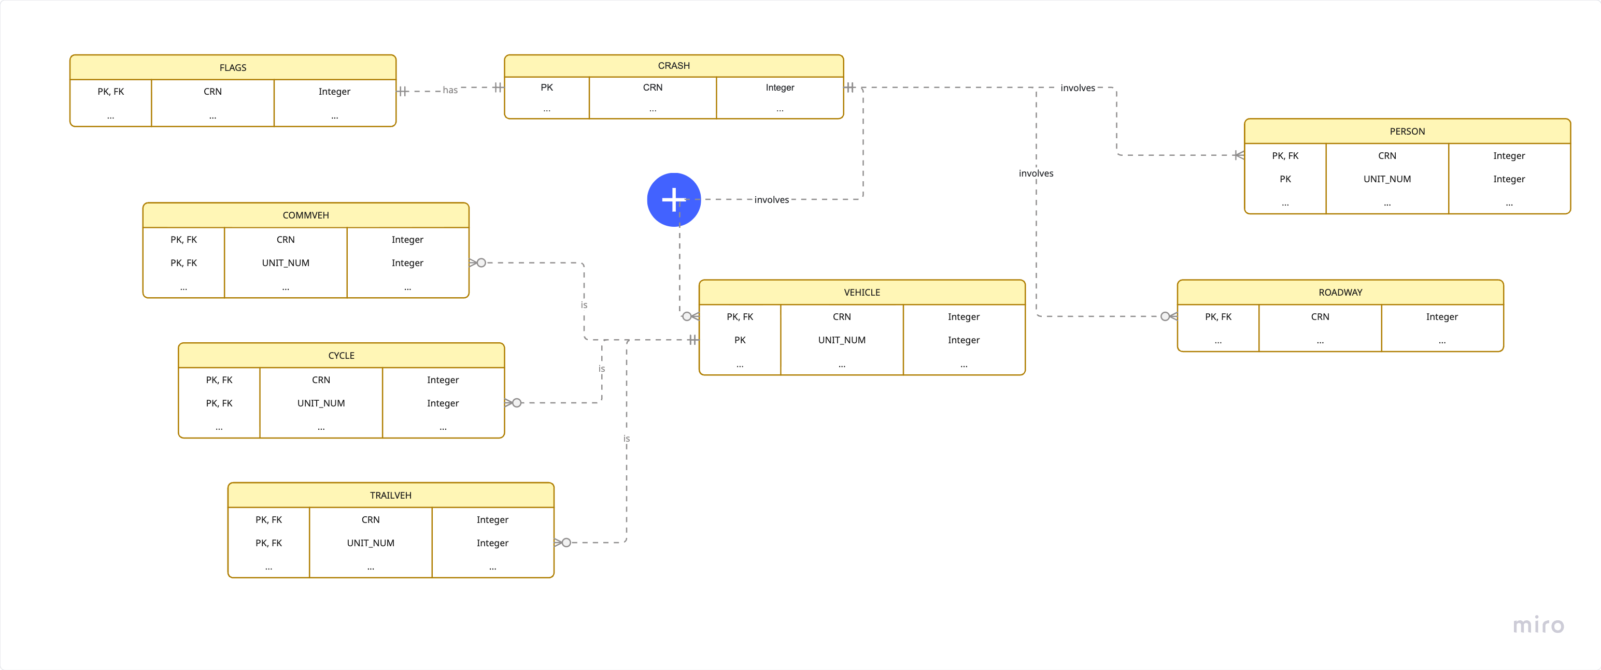

Temporal Coverage and Granularity
Data for this project are from public datasets about crashes in the Commonwealth of Pennsylvania from 2005 through 2024. The year and month of a crash is the temporal frequency of the public dataset. The specific day on which the crash occurred is missing, and the time the police arrived is missing from most records.

Data Volume and Scale
All 160 datasets (8 files for each year over 20 years) require 4.18 GB of disk space for storage. The crash dataset has 2,461,193 records.
For this project, selected data include variables from the crash and flags datasets that are associated with factors that existed before the crash. For example, the aggressive driving variables, vehicle type indicators, school and work zone indicators, driver age counts, weather, location type, and road conditions are included. Variables that are related to injuries, fatalities, number of vehicles involved, changed traffic patterns after the crash, and crash site cleanup are excluded. These variables would answer questions related to the severity of crashes, but those questions do not relate to the business objectives. The crash and flags datasets have enough information to control for age (young_driver and driver_count_<age>), road conditions (road_condition), location type (location_type), and county or urban vs. rural (county and urban_rural).

Categorical Variable Encoding
The following crash fields are coded or have abbreviations. See Appendix C: Coded crash Variable Fields and Appendix D: Enumeration of Counties for the definitions and full values for each field.
- county
- day_of_week
- illumination
- intersect_type
- location_type
- road_condition
- urban_rural
- weather1
- weather2

2.3 Data Exploration
New variables related to the crash date, month, and day were created for use in the exploration.
- crash_date is a timestamp variable created using the crash month and year. The day of the month was set to 01. This variable is used for grouping and displaying time series plots.
- crash_mn_name is a text variable derived from the numeric month to have a readable month to display on any visualizations.
- post_covid is a binary (0, 1) variable where 0=before COVID and 1=after COVID. Dates before January 1, 2020 were marked as before COVID and dates on or after January 1, 2020 were marked as after COVID. The chosen cut-off for pre- and post-COVID may need to be adjusted.

Univariate Analysis
The following count plot of the distribution of aggressive_driving, shows that more crashes occur when one or more aggressive driving behaviors were present than when no aggressive driving behaviors were.
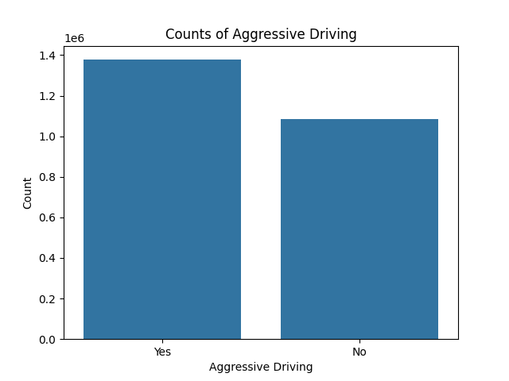
The following count plot of the distribution of aggressive_driving whetheer the crash occurred before or after COVID shows how unbalanced the dataset is with many more crash records from before COVID (2005 through 2019) than those after (2020 through 2024). The trend from 2005 -2024 is important to study so these counts were turned into rates to visualize the time series in the next section.
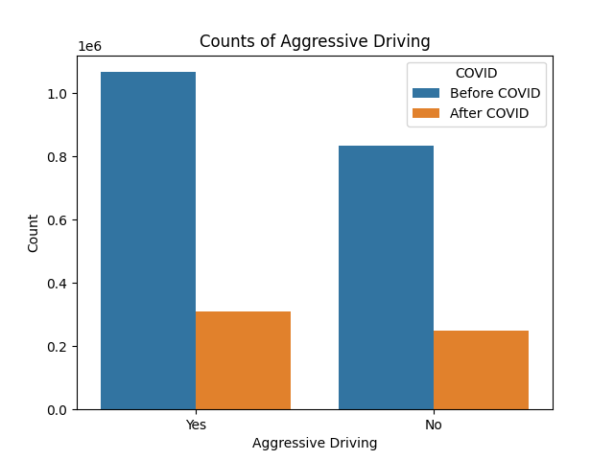

Bivariate Relationships with Temporal Patterns and Trends
The rate of aggressive driving overall and of specific behaviors was calculated as the number of crashes where aggressive driving was exhibited divided by the total number of crashes. This was aggregated monthly.
There is an aggressive_driving variable in the flags dataset that indicates that one or more aggressive driving behaviors were present during the crash. There are also variables for several specific types of aggressive driving behaviors. The following figures show some of these behaviors over time. The components of the time series including trend, seasonality, cyclicality, and noise, will be evaluated later.
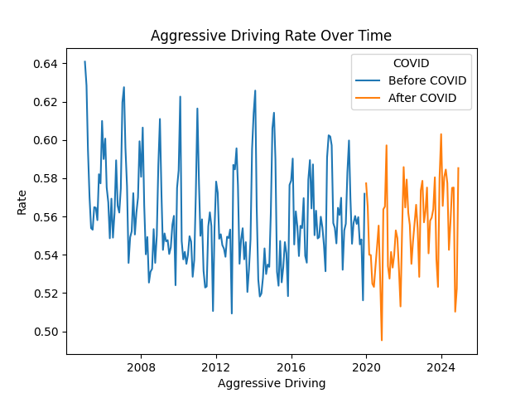 | When considering aggressive driving as a single action that includes one or more specific aggressive behaviors, it appears that aggressive driving does not increase with COVID.
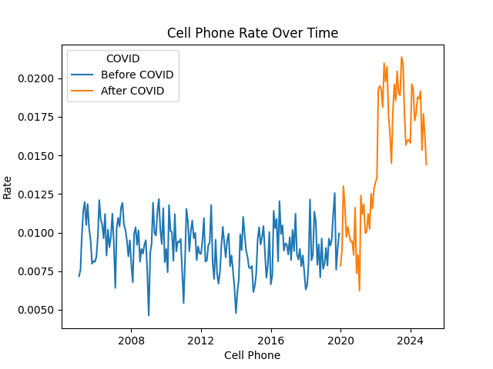 | The use of cell phones while driving spiked after COVID between 2022 and 2023.
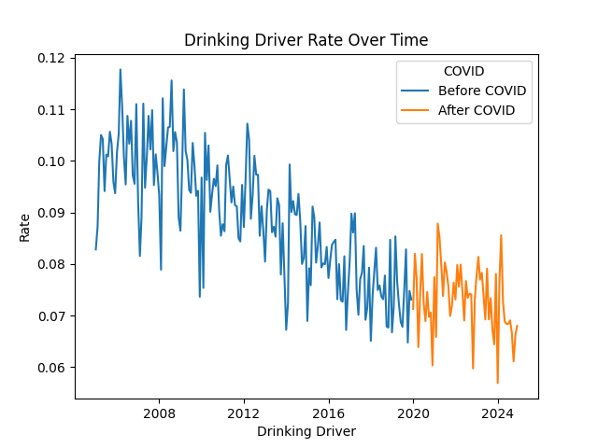 | The drinking driving rate was in decline until COVID and then plateaued at the beginning of the pandemic.
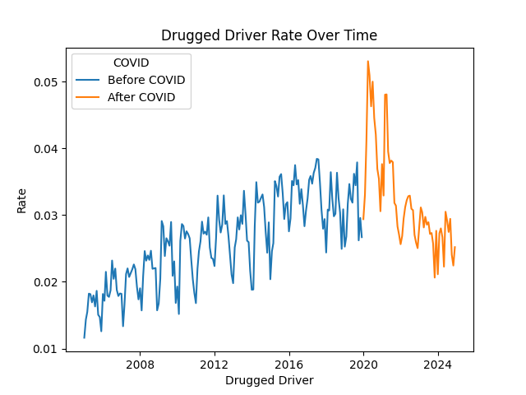 | The drugged driver rate spiked at the start of COVID and then began to decline starting in 2021 or 2022.
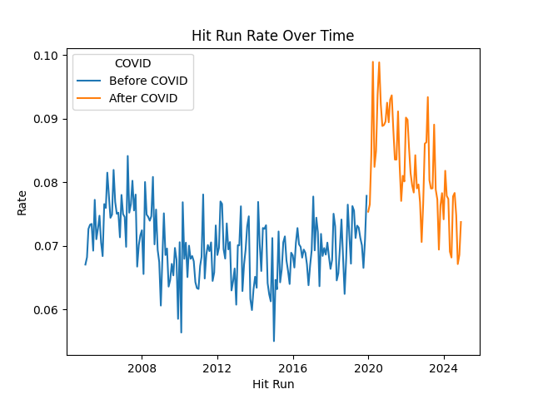 | The hit and run rate spiked at the start of COVID and has been slowly declining since.
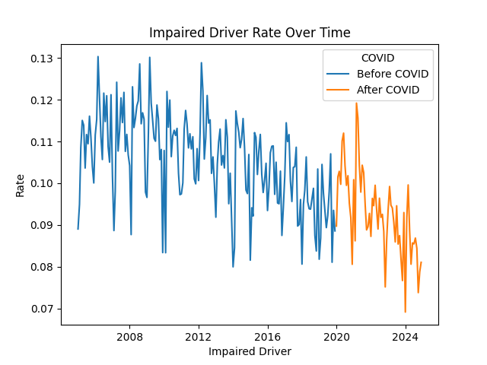 | The impaired driver rate spiked a little bit during COVID in 2020 and into 2022 but has been declining since.
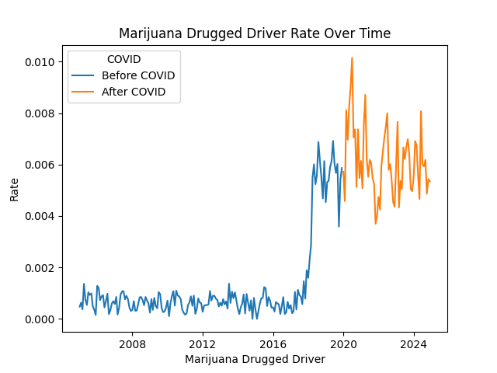 | The marijuana drugged driver rate spike around 2018 before COVID and then spiked again during COVID. The trend has plateaued but remains high.
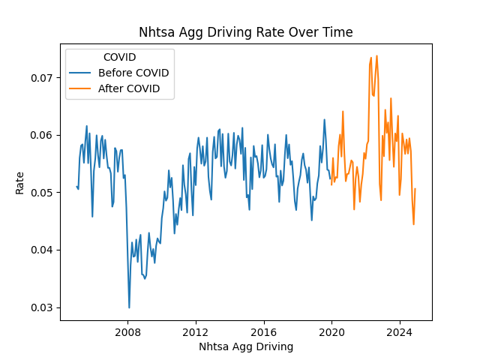 | The NHTSA aggressive driving rate spiked in 2022 or 2023 and then declined to be closer to what it was from 2012 to 2018.
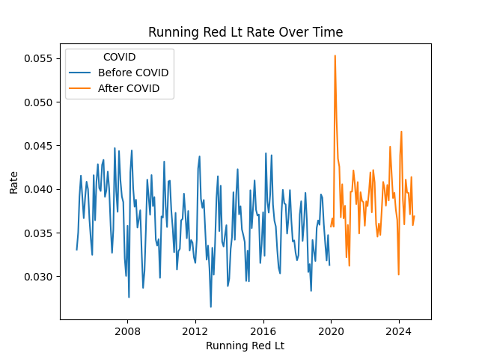 | The rate of people running red lights spiked at the beginning of COVID and then declined. The trend remains a little higher than it was prior to COVID.
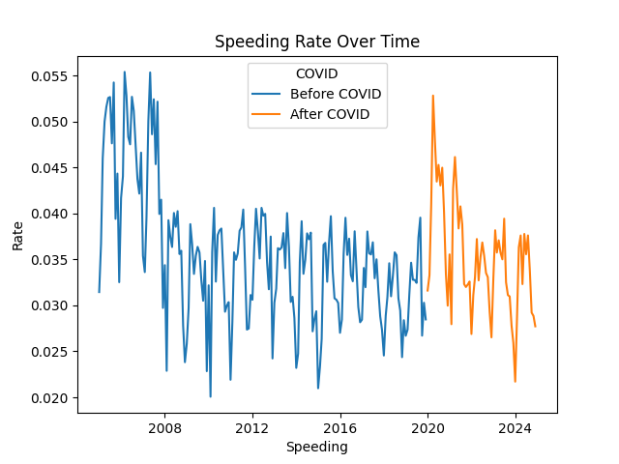 | The speeding rate was high before 2008 but dropped significantly between 2008 and 2020 when it spiked again. The trend declined around 2022 to a rate closer to what it was from 2008 to 2020.
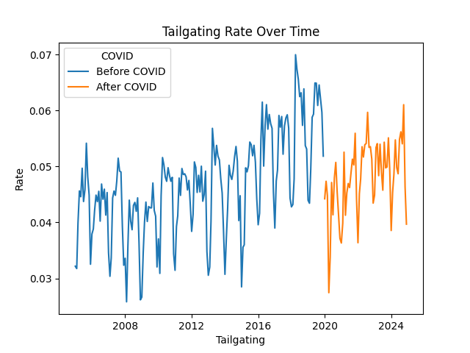 | The tailgating rate dropped in 2020 and has been increasing since.
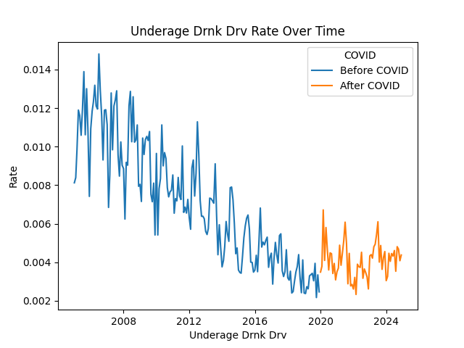 | The underage drinking rate was declining before COVID. The trend plateaued in 2020 and remains steady.

Hypothesis Generation
It is surprising that specific aggressive driving behaviors, such as drugged driver rate and hit and run, spiked at the beginning of COVID while the overall aggressive driving rate did not appear to increase at the same time. This may be because aggressive drivers engage in more than one specific behavior, and engaging in more aggressive driving behaviors is what increased. This could result in a higher rate of crashes due to aggressive driving and may explain why people agree that aggressive driving behaviors increased with COVID. An increase in the number of behaviors drivers engage in could make their aggressiveness more noticeable and dangerous.

2.4 Data Quality Assessment
Appendix A: Data Dictionary for CRASH and Appendix B: Data Dictionary for FLAGS show the number and percentage of missing values for each selected field in the crash and flags datasets, respectively.

Completeness Analysis
The variables below have significant missingness. and will be removed from the dataset:
- illumination has 2,448,908 (99.5%) missing values.
- weather1 has 2,315,023 (94.1%) missing values.
- weather2 has 2,161,825 (87.8%) missing values.
The following variables have 0 (0.0%) missing values:
- All flags variables
- crash_month, crash_year, and day_of_week
- All driver_count_<age> variables
- county and urban_rural
- intersect_type
- location_type
- road_condition

Accuracy Assessment
The flags dataset contains some variables whose values correspond in some ways to the crash fields above.
The illumination_dark field from flags, is 1 when illumination is ‘Dark streetlights’, ‘Dark - no streetlights’, or ‘Dark unknown roadway lighting.’ However, illumination_dark is also 1 when illumination is null for 817,191 records. The weather1 and weather2 fields were not used to derive illumination_dark because all values of weather are represented when illumination_dark is 1.
The intersection and non_intersection field from flags, corresponds with intersect_type where intersection is 1 for all values of intersect_type except ‘Mid-block’ and non_intersection is 1 for ‘Mid-block.’
The cross_median, curve_dvr_error, curved_road, ramp, ramp_segment, ramp_terminal, roundabout, or speed_change_lane fields from flags do not appear to correspond with the location_type field from crash.
The icy_road, snow_slush_road, and wet_road fields from flags correspond perfectly with road_condition values from crash. When icy_road is 1, road_condition is ‘'Ice/Frost'; when snow_slush_road is 1, road_condition is ‘Snow’ or ‘Slush’; and when wet_road is 1, road_condition is ‘Wet’ or ‘Water (Standing or Moving).’
The urban and rural fields from flags mostly correspond with urban_rural values from crash, which allows for ‘Urban’, ‘Rural,’ and ‘Urbanized’ values. The rural field is 1 for 818,102 values of ‘Rural’ and 6,220 for ‘Urbanized’ while the urban field is 1 for 1,636,862 values of ‘Urbanized’ and 0 for 9 values of ‘Rural.’ There are no instances of ‘Urban,’ and it is unclear what ‘Urbanized’ means. It could mean a small urban-like town in an otherwise rural area.
The driver_<age> variables from flags mostly correspond with the respective driver_count_<age> variables in crash. For each count variable in crash, there are a few values for which the count is 0 while the respective flags variable is 1, however, these account for less than 0.00005% of records for each variable. Otherwise, the flags variables are 1 when the count variables in crash are greater than 0.
Due to the nature of how these data were compiled and prepared for public consumption, it is not possible to verify the accuracy of the data. However, the primary variables chosen for this report have no missing values, and the correspondence between similar variables in crash and flags is fairly consistent. The data appear to be accurate and can be used for analysis.

Consistency Evaluation
There are some inconsistencies between the flags variables and their possible corresponding categorical variables in crash. There is no need to use similar variables from both datasets, or example, this project does not use both intersect_type from crash and intersection and non_intersection from flags. Temporal and geographic variables from crash are used for grouping and summarizing, and rates of occurrence of flags variables are analyzed within these temporal or geographic categories. flags variables that do not represent an aggressive driving behavior, such as driver_<age>, are used to analyze covariance with aggressive driving.

crn
There are no crn values in other datasets that are not in crash. Every record in crash has a corresponding record in flags.

Timelines and Currency
The data are current for the timeline of this project. The trend of various flags categories is well established since it starts in 2005 so changes can be easily visualized and analyzed.

Relevance and Coverage
The data include crashes for the state of Pennsylvania. All counties are represented in the data.

Data Quality and Impact Assessment
The variables illumination, weather1, and weather2 that were originally chosen for this project have 99.5%, 94.1%, and 87.8% missing values, respectively. It would not make sense to impute that many values. All other variables chosen for this project have 0 missing values. The dataset is in good condition for analysis.

Appendix A: Data Dictionary for CRASH
Column | Description (PENNDOT, 2025) | Data Type | Number of Unique | Missing | Range/Unique
COUNTY | County in PA where the crash occurred | int64 | 67 | 0 (0.0%) | [1, 67]
CRASH_MONTH | Month of the crash date | int64 | 12 | 0 (0.0%) | [1, 12]
CRASH_YEAR | Year of the crash | int64 | 20 | 0 (0.0%) | [2005, 2024]
CRN (PK) | Crash record number - unique identifier | int64 | 2461193 | 0 (0.0%) | [2005000003, 2025050430]
DAY_OF_WEEK | Day of week that the crash occurred | int64 | 7 | 0 (0.0%) | [1, 7]
DRIVER_COUNT_16YR | Number of 16-year-old drivers involved in the crash | int64 | 5 | 0 (0.0%) | [0, 4]
DRIVER_COUNT_17YR | Number of 17-year-old drivers involved in the crash | int64 | 7 | 0 (0.0%) | [0, 6]
DRIVER_COUNT_18YR | Number of 18-year-old drivers involved in the crash | int64 | 6 | 0 (0.0%) | [0, 5]
DRIVER_COUNT_19YR | Number of 19-year-old drivers involved in the crash | int64 | 5 | 0 (0.0%) | [0, 4]
DRIVER_COUNT_20YR | Number of 20-year-old drivers involved in the crash | int64 | 4 | 0 (0.0%) | [0, 3]
DRIVER_COUNT_50_64YR | Number of 50 to 64-year-old drivers involved in the crash | int64 | 16 | 0 (0.0%) | [0, 26]
DRIVER_COUNT_65_74YR | Number of 65 to 74-year-old drivers involved in the crash | int64 | 7 | 0 (0.0%) | [0, 7]
DRIVER_COUNT_75PLUS | Number of 75-year-old and older drivers involved in the crash | int64 | 5 | 0 (0.0%) | [0, 4]
ILLUMINATION † | Code that identifies the lighting at the time of the crash in terms time of day and existence of street lights | float64 | 7 | 2448908 (99.5%) | [1.0, 8.0]
INTERSECT_TYPE † | Code that identifies the type of intersection, if applicable, where the crash occurred | int64 | 14 | 0 (0.0%) | [0, 99]
LOCATION_TYPE † | Code that identifies the type of location where the crash occurred | int64 | 10 | 0 (0.0%) | [0, 99]
ROAD_CONDITION † | Code that identifies the condition of the road | int64 | 11 | 0 (0.0%) | [1, 99]
SECONDARY_CRASH † | Did a prior crash contribute in any way to this crash? | string | 2 | 1884162 (76.55%) | <NA>, N, Y
URBAN_RURAL † | Code that identifies the location of the crash as either urban or rural | int64 | 2 | 0 (0.0%) | [1, 2]
WEATHER1 † | Code that identifies the primary weather condition at the time of the crash | float64 | 12 | 2315023 (94.06%) | [1.0, 99.0]
WEATHER2 † | Code that identifies the secondary weather condition at the time of the crash | float64 | 11 | 2161825 (87.84%) | [1.0, 98.0]

† See Appendix C: Coded crash Variable Fields and Appendix D: Enumeration of Counties for the definitions of enumerated values for each field.

Appendix B: Data Dictionary for FLAGS
Column | Definition (PENNDOT, 2025) | Data Type | Number of Unique | Missing | Range/Unique
AGGRESSIVE_DRIVING | At least one aggressive driver action | int64 | 2 | 0 (0.0%) | [0, 1]
ALCOHOL_RELATED | At least one driver or pedestrian was reported or suspected of alcohol use | int64 | 2 | 0 (0.0%) | [0, 1]
CELL_PHONE | Driver was using a cell phone, either hand held or hands free | int64 | 2 | 0 (0.0%) | [0, 1]
CRN (PK, FK) | Crash record number - unique identifier | int64 | 2461193 | 0 (0.0%) | [2005000003, 2025050430]
CROSS_MEDIAN | At least one unit crossed a median | int64 | 2 | 0 (0.0%) | [0, 1]
CURVE_DVR_ERROR | At least one driver error in curve negotiation | int64 | 2 | 0 (0.0%) | [0, 1]
CURVED_ROAD | A curve in the road where the crash occurred | int64 | 2 | 0 (0.0%) | [0, 1]
DISTRACTED | At least one driver action occurred because of distraction | int64 | 2 | 0 (0.0%) | [0, 1]
DRINKING_DRIVER | At least one driver was drinking | int64 | 2 | 0 (0.0%) | [0, 1]
DRIVER_16YR | At least one driver was 16 years of age | int64 | 2 | 0 (0.0%) | [0, 1]
DRIVER_17YR | At least one driver was 17 years of age | int64 | 2 | 0 (0.0%) | [0, 1]
DRIVER_18YR | At least one driver was 18 years of age | int64 | 2 | 0 (0.0%) | [0, 1]
DRIVER_19YR | At least one driver was 19 years of age | int64 | 2 | 0 (0.0%) | [0, 1]
DRIVER_20YR | At least one driver was 20 years of age | int64 | 2 | 0 (0.0%) | [0, 1]
DRIVER_50_64YR | At least one driver was 50 to 64 years of age | int64 | 2 | 0 (0.0%) | [0, 1]
DRIVER_65_74YR | At least one driver was 65 to 74 years of age | int64 | 2 | 0 (0.0%) | [0, 1]
DRIVER_75PLUS | At least one driver was 75 years of age or older | int64 | 2 | 0 (0.0%) | [0, 1]
DRUG_RELATED | A driver or non-motorist (cyclist or pedestrian) had a condition of drug use, was suspected of drug use by the police, or had a positive drug test indicating the presence of a controlled substance (this definition changed in May 2022) | int64 | 2 | 0 (0.0%) | [0, 1]
DRUGGED_DRIVER | Any driver had a condition of drug use, was suspected of drug use by the police, or had a positive drug test indicating the presence of a controlled substance (this definition changed in May 2022) | int64 | 2 | 0 (0.0%) | [0, 1]
FATIGUE_ASLEEP | At least one driver was fatigued or fell asleep | int64 | 2 | 0 (0.0%) | [0, 1]
HIT_RUN | At least one driver engaged in hit and run | int64 | 2 | 0 (0.0%) | [0, 1]
ICY_ROAD | Road was icy at the time of the crash | int64 | 2 | 0 (0.0%) | [0, 1]
ILLEGAL_DRUG_RELATED | At least one driver or pedestrian was reported or suspected of using illegal drugs | int64 | 2 | 0 (0.0%) | [0, 1]
ILLUMINATION_DARK | Crash site lighting was dark | int64 | 2 | 0 (0.0%) | [0, 1]
IMPAIRED_DRIVER | At least one driver was impaired by drugs or alcohol | int64 | 2 | 0 (0.0%) | [0, 1]
IMPAIRED_NONMOTORIST | At least one non-motorist was impaired by drugs or alcohol | int64 | 2 | 0 (0.0%) | [0, 1]
INTERSECTION | Crash occurred at an intersection | int64 | 2 | 0 (0.0%) | [0, 1]
LANE_DEPARTURE | At least one driver departed their lane of travel during the crash | int64 | 2 | 0 (0.0%) | [0, 1]
MARIJUANA_DRUGGED_DRIVER | At least one driver tested positive for marijuana | int64 | 2 | 0 (0.0%) | [0, 1]
MARIJUANA_RELATED | At least one driver, pedestrian, or other non-motorist tested positive for marijuana | int64 | 2 | 0 (0.0%) | [0, 1]
MATURE_DRIVER | At least one driver was over the age of 65 | int64 | 2 | 0 (0.0%) | [0, 1]
MC_DRINKING_DRIVER | At least one motorcycle driver was reported or suspected of alcohol use | int64 | 2 | 0 (0.0%) | [0, 1]
NHTSA_AGG_DRIVING | The crash meets the definition for aggressive driving established by NHTSA | int64 | 2 | 0 (0.0%) | [0, 1]
NON_INTERSECTION | Crash did not take place at an intersection | int64 | 2 | 0 (0.0%) | [0, 1]
OPIOID_RELATED | At least one motorcycle driver was reported or suspected of drug use and tested positive for opioids | int64 | 2 | 0 (0.0%) | [0, 1]
RAMP | Crash involved an interchange ramp | int64 | 2 | 0 (0.0%) | [0, 1]
RAMP_SEGMENT | Crash occurred on an interchange ramp between the beginning and end of the ramp | int64 | 2 | 0 (0.0%) | [0, 1]
RAMP_TERMINAL | Crash occurred at the end of an interchange ramp where a limited access highway meets a non-limited access highway | int64 | 2 | 0 (0.0%) | [0, 1]
ROUNDABOUT | Crash occurred at a modern roundabout intersection | int64 | 2 | 0 (0.0%) | [0, 1]
RUNNING_RED_LT | At least one driver ran a red light | int64 | 2 | 0 (0.0%) | [0, 1]
RUNNING_STOP_SIGN | At least one driver ran a stop sign | int64 | 2 | 0 (0.0%) | [0, 1]
RURAL | Crash occurred in a rural municipality | int64 | 2 | 0 (0.0%) | [0, 1]
SIGNALIZED_INT | Crash occurred at a signalized intersection | int64 | 2 | 0 (0.0%) | [0, 1]
SNOW_SLUSH_ROAD | Either snow or slush was on the road when the crash occurred | int64 | 2 | 0 (0.0%) | [0, 1]
SPEED_CHANGE_LANE | Crash occurred where an acceleration and deceleration lane was present on a limited access highway | int64 | 2 | 0 (0.0%) | [0, 1]
SPEEDING | At least one driver was speeding | int64 | 2 | 0 (0.0%) | [0, 1]
SPEEDING_RELATED | At least one driver was speeding, racing, or driving too fast for conditions | int64 | 2 | 0 (0.0%) | [0, 1]
STOP_CONTROLLED_INT | Crash occurred at a stop controlled intersection | int64 | 2 | 0 (0.0%) | [0, 1]
SUDDEN_DEER | Crash involved a deer in the roadway | int64 | 2 | 0 (0.0%) | [0, 1]
TAILGATING | At least one driver was tailgating or following too closely | int64 | 2 | 0 (0.0%) | [0, 1]
UNDERAGE_DRNK_DRV | At least one driver was underage and drinking | int64 | 2 | 0 (0.0%) | [0, 1]
UNLICENSED | At least one driver was unlicensed | int64 | 2 | 0 (0.0%) | [0, 1]
UNSIGNALIZED_INT | Crash occurred at an unsignalized intersection | int64 | 2 | 0 (0.0%) | [0, 1]
URBAN | Crash occurred in a n urban municipality | int64 | 2 | 0 (0.0%) | [0, 1]
WET_ROAD | Road was wet at the time of the crash | int64 | 2 | 0 (0.0%) | [0, 1]
YOUNG_DRIVER | At least one driver action occurred because of distraction | int64 | 2 | 0 (0.0%) | [0, 1]

Appendix C: Coded crash Variable Fields
county  See Error! Not a valid bookmark self-reference.  day_of_week  1: 'Sunday'  2: 'Monday'  3: 'Tuesday'  4: 'Wednesday'  5: 'Thursday'  6: 'Friday'  7: 'Saturday'  9: ‘Unknown  illumination  1: 'Daylight'  2: 'Dark - no streetlights'  3: 'Dark streetlights'  4: 'Dusk'  5: 'Dawn'  6: 'Dark unknown roadway lighting'  8: 'Other'  9: 'Unknown'  intersect_type  0: 'Mid-block'  1: 'Four-way intersection'  2: '“T” intersection'  3: '“Y” intersection'  4: 'Traffic Circle/Roundabout (EXPIRED 1/1/18)'  5: 'Multi-leg intersection'  6: 'Ramp End'  7: 'Ramp Begin'  8: 'Crossover'  9: 'Railroad crossing'  10: 'Other'  11: '“L” Intersection'  12: 'Traffic Circle'  13: 'Roundabout'  99: 'Unknown'  location_type  0: 'Not applicable'  1: 'Underpass'  2: 'Ramp'  3: 'Bridge'  4: 'Tunnel'  5: 'Toll Booth'  6: 'Cross over related'  7: 'Driveway or Parking Lot'  8: 'Ramp and bridge'  99: 'Unknown' | road_condition  1: 'Dry'  2: 'Ice/Frost'  3: 'Mud, Dirt, Gravel'  4: 'Oil'  5: 'Sand'  6: 'Slush'  7: 'Snow'  8: 'Water (Standing or Moving)'  9: 'Wet'  22: 'Mud, Sand, Dirt, Oil (Expired 1-1-20)'  98: 'Other'  99: 'Unknown'  secondary_crash  Y: 'Yes'  N: 'No'  <NA>: missing  urban_rural  1: 'Rural'  2: 'Urbanized'  3: 'Urban'  weather1/weather2  1: 'Blowing Sand, Soil, Dirt'  2: 'Blowing Snow'  3: 'Clear'  4: 'Cloudy'  5: 'Fog, Smog, Smoke'  6: 'Freezing Rain or Freezing Drizzle'  7: 'Rain'  8: 'Severe Crosswinds'  9: 'Sleet or Hail'  10: 'Snow'  98: 'Other'  99: 'Unknown' ‡  ‡ weather1 only

Appendix D: Enumeration of Counties

County | Enumeration |  | County | Enumeration
ADAMS | 1 |  | LANCASTER | 36
ALLEGHENY | 2 |  | LAWRENCE | 37
ARMSTRONG | 3 |  | LEBANON | 38
BEAVER | 4 |  | LEHIGH | 39
BEDFORD | 5 |  | LUZERNE | 40
BERKS | 6 |  | LYCOMING | 41
BLAIR | 7 |  | MCKEAN | 42
BRADFORD | 8 |  | MERCER | 43
BUCKS | 9 |  | MIFFLIN | 44
BUTLER | 10 |  | MONROE | 45
CAMBRIA | 11 |  | MONTGOMERY | 46
CAMERON | 12 |  | MONTOUR | 47
CARBON | 13 |  | NORTHAMPTON | 48
CENTRE | 14 |  | NORTHUMBERLAND | 49
CHESTER | 15 |  | PERRY | 50
CLARION | 16 |  | PIKE | 51
CLEARFIELD | 17 |  | POTTER | 52
CLINTON | 18 |  | SCHUYLKILL | 53
COLUMBIA | 19 |  | SNYDER | 54
CRAWFORD | 20 |  | SOMERSET | 55
CUMBERLAND | 21 |  | SULLIVAN | 56
DAUPHIN | 22 |  | SUSQUEHANNA | 57
DELAWARE | 23 |  | TIOGA | 58
ELK | 24 |  | UNION | 59
ERIE | 25 |  | VENANGO | 60
FAYETTE | 26 |  | WARREN | 61
FOREST | 27 |  | WASHINGTON | 62
FRANKLIN | 28 |  | WAYNE | 63
FULTON | 29 |  | WESTMORELAND | 64
GREENE | 30 |  | WYOMING | 65
HUNTINGDON | 31 |  | YORK | 66
INDIANA | 32 |  | PHILADELPHIA | 67
JEFFERSON | 33
JUNIATA | 34
LACKAWANNA | 35

Appendix E: File Information
Each file from the PennDOT Crash Data Download portal consists of tabular data in a comma separated values (CSV) file. The table below displays the year, file path, file size, number of rows, and number of columns for each dataset.
Year | File Path | File Size (MB) | Number of Rows | Number of Columns
2005 | data/raw/Statewide_2005/COMMVEH_2005.csv | 1.52 | 8415 | 32
2005 | data/raw/Statewide_2005/CRASH_2005.csv | 54.15 | 134,261 | 99
2005 | data/raw/Statewide_2005/CYCLE_2005.csv | 0.48 | 5,788 | 21
2005 | data/raw/Statewide_2005/FLAGS_2005.csv | 68.38 | 134,261 | 130
2005 | data/raw/Statewide_2005/PERSON_2005.csv | 32.32 | 323,241 | 23
2005 | data/raw/Statewide_2005/ROADWAY_2005.csv | 15.76 | 204,591 | 13
2005 | data/raw/Statewide_2005/TRAILVEH_2005.csv | 0.4 | 9,801 | 8
2005 | data/raw/Statewide_2005/VEHICLE_2005.csv | 43.05 | 236,909 | 41
2006 | data/raw/Statewide_2006/COMMVEH_2006.csv | 1.35 | 7,450 | 32
2006 | data/raw/Statewide_2006/CRASH_2006.csv | 52.5 | 129,253 | 99
2006 | data/raw/Statewide_2006/CYCLE_2006.csv | 0.46 | 5,571 | 21
2006 | data/raw/Statewide_2006/FLAGS_2006.csv | 65.83 | 129,253 | 130
2006 | data/raw/Statewide_2006/PERSON_2006.csv | 31.17 | 311,602 | 23
2006 | data/raw/Statewide_2006/ROADWAY_2006.csv | 15.47 | 200,835 | 13
2006 | data/raw/Statewide_2006/TRAILVEH_2006.csv | 0.27 | 6,140 | 8
2006 | data/raw/Statewide_2006/VEHICLE_2006.csv | 41.87 | 229,365 | 41
2007 | data/raw/Statewide_2007/COMMVEH_2007.csv | 1.53 | 8,448 | 32
2007 | data/raw/Statewide_2007/CRASH_2007.csv | 54.72 | 132,152 | 99
2007 | data/raw/Statewide_2007/CYCLE_2007.csv | 0.48 | 5,811 | 21
2007 | data/raw/Statewide_2007/FLAGS_2007.csv | 67.3 | 132,152 | 130
2007 | data/raw/Statewide_2007/PERSON_2007.csv | 31.4 | 313,795 | 23
2007 | data/raw/Statewide_2007/ROADWAY_2007.csv | 15.31 | 198,628 | 13
2007 | data/raw/Statewide_2007/TRAILVEH_2007.csv | 0.3 | 6,989 | 8
2007 | data/raw/Statewide_2007/VEHICLE_2007.csv | 42.24 | 231,408 | 41
2008 | data/raw/Statewide_2008/COMMVEH_2008.csv | 1.36 | 7,512 | 32
2008 | data/raw/Statewide_2008/CRASH_2008.csv | 51.96 | 126,184 | 99
2008 | data/raw/Statewide_2008/CYCLE_2008.csv | 0.45 | 5,254 | 21
2008 | data/raw/Statewide_2008/FLAGS_2008.csv | 64.26 | 126,184 | 130
2008 | data/raw/Statewide_2008/PERSON_2008.csv | 29.49 | 293,312 | 23
2008 | data/raw/Statewide_2008/ROADWAY_2008.csv | 14.54 | 187,973 | 13
2008 | data/raw/Statewide_2008/TRAILVEH_2008.csv | 0.26 | 5,651 | 8
2008 | data/raw/Statewide_2008/VEHICLE_2008.csv | 39.81 | 218,713 | 41
2009 | data/raw/Statewide_2009/COMMVEH_2009.csv | 1.2 | 6,620 | 32
2009 | data/raw/Statewide_2009/CRASH_2009.csv | 50.13 | 121,794 | 99
2009 | data/raw/Statewide_2009/CYCLE_2009.csv | 0.41 | 4,854 | 21
2009 | data/raw/Statewide_2009/FLAGS_2009.csv | 62.03 | 121,794 | 130
2009 | data/raw/Statewide_2009/PERSON_2009.csv | 28.93 | 287,324 | 23
2009 | data/raw/Statewide_2009/ROADWAY_2009.csv | 14.5 | 186,702 | 13
2009 | data/raw/Statewide_2009/TRAILVEH_2009.csv | 0.21 | 4,520 | 8
2009 | data/raw/Statewide_2009/VEHICLE_2009.csv | 38.82 | 213,217 | 41
2010 | data/raw/Statewide_2010/COMMVEH_2010.csv | 1.33 | 7,307 | 32
2010 | data/raw/Statewide_2010/CRASH_2010.csv | 50.08 | 121,612 | 99
2010 | data/raw/Statewide_2010/CYCLE_2010.csv | 0.44 | 5,233 | 21
2010 | data/raw/Statewide_2010/FLAGS_2010.csv | 61.93 | 121,612 | 130
2010 | data/raw/Statewide_2010/PERSON_2010.csv | 29.14 | 289,421 | 23
2010 | data/raw/Statewide_2010/ROADWAY_2010.csv | 14.66 | 188,530 | 13
2010 | data/raw/Statewide_2010/TRAILVEH_2010.csv | 0.24 | 5,001 | 8
2010 | data/raw/Statewide_2010/VEHICLE_2010.csv | 39.29 | 215,820 | 41
2011 | data/raw/Statewide_2011/COMMVEH_2011.csv | 1.43 | 7,846 | 32
2011 | data/raw/Statewide_2011/CRASH_2011.csv | 51.79 | 125,616 | 99
2011 | data/raw/Statewide_2011/CYCLE_2011.csv | 0.39 | 4,674 | 21
2011 | data/raw/Statewide_2011/FLAGS_2011.csv | 63.97 | 125,616 | 130
2011 | data/raw/Statewide_2011/PERSON_2011.csv | 30.6 | 294,523 | 23
2011 | data/raw/Statewide_2011/ROADWAY_2011.csv | 15.2 | 195,679 | 13
2011 | data/raw/Statewide_2011/TRAILVEH_2011.csv | 0.26 | 5,402 | 8
2011 | data/raw/Statewide_2011/VEHICLE_2011.csv | 40.27 | 221,514 | 41
2012 | data/raw/Statewide_2012/COMMVEH_2012.csv | 1.31 | 7,220 | 32
2012 | data/raw/Statewide_2012/CRASH_2012.csv | 51.83 | 124,501 | 99
2012 | data/raw/Statewide_2012/CYCLE_2012.csv | 0.43 | 5,139 | 21
2012 | data/raw/Statewide_2012/FLAGS_2012.csv | 63.41 | 124,501 | 130
2012 | data/raw/Statewide_2012/PERSON_2012.csv | 30.26 | 291,142 | 23
2012 | data/raw/Statewide_2012/ROADWAY_2012.csv | 15.21 | 195,822 | 13
2012 | data/raw/Statewide_2012/TRAILVEH_2012.csv | 0.24 | 5,154 | 8
2012 | data/raw/Statewide_2012/VEHICLE_2012.csv | 40.03 | 220,251 | 41
2013 | data/raw/Statewide_2013/COMMVEH_2013.csv | 1.36 | 7,517 | 32
2013 | data/raw/Statewide_2013/CRASH_2013.csv | 51.42 | 124,366 | 99
2013 | data/raw/Statewide_2013/CYCLE_2013.csv | 0.39 | 4,732 | 21
2013 | data/raw/Statewide_2013/FLAGS_2013.csv | 63.34 | 124,366 | 130
2013 | data/raw/Statewide_2013/PERSON_2013.csv | 28.92 | 287,126 | 23
2013 | data/raw/Statewide_2013/ROADWAY_2013.csv | 15.16 | 194,817 | 13
2013 | data/raw/Statewide_2013/TRAILVEH_2013.csv | 0.25 | 5,284 | 8
2013 | data/raw/Statewide_2013/VEHICLE_2013.csv | 39.79 | 218,867 | 41
2014 | data/raw/Statewide_2014/COMMVEH_2014.csv | 1.46 | 8,070 | 32
2014 | data/raw/Statewide_2014/CRASH_2014.csv | 50.24 | 121,547 | 99
2014 | data/raw/Statewide_2014/CYCLE_2014.csv | 0.38 | 4,590 | 21
2014 | data/raw/Statewide_2014/FLAGS_2014.csv | 61.9 | 121,547 | 130
2014 | data/raw/Statewide_2014/PERSON_2014.csv | 28.19 | 279,913 | 23
2014 | data/raw/Statewide_2014/ROADWAY_2014.csv | 14.61 | 188,456 | 13
2014 | data/raw/Statewide_2014/TRAILVEH_2014.csv | 0.27 | 5,608 | 8
2014 | data/raw/Statewide_2014/VEHICLE_2014.csv | 39.07 | 215,299 | 41
2015 | data/raw/Statewide_2015/COMMVEH_2015.csv | 1.55 | 8,548 | 32
2015 | data/raw/Statewide_2015/CRASH_2015.csv | 52.69 | 127,470 | 99
2015 | data/raw/Statewide_2015/CYCLE_2015.csv | 0.38 | 4,532 | 21
2015 | data/raw/Statewide_2015/FLAGS_2015.csv | 64.92 | 127,470 | 130
2015 | data/raw/Statewide_2015/PERSON_2015.csv | 29.58 | 293,690 | 23
2015 | data/raw/Statewide_2015/ROADWAY_2015.csv | 15.3 | 197,547 | 13
2015 | data/raw/Statewide_2015/TRAILVEH_2015.csv | 0.29 | 6,099 | 8
2015 | data/raw/Statewide_2015/VEHICLE_2015.csv | 41.14 | 226,713 | 41
2016 | data/raw/Statewide_2016/COMMVEH_2016.csv | 1.52 | 8,411 | 32
2016 | data/raw/Statewide_2016/CRASH_2016.csv | 53.44 | 129,607 | 99
2016 | data/raw/Statewide_2016/CYCLE_2016.csv | 0.39 | 4,653 | 21
2016 | data/raw/Statewide_2016/FLAGS_2016.csv | 66.01 | 129,607 | 130
2016 | data/raw/Statewide_2016/PERSON_2016.csv | 30.33 | 300,497 | 23
2016 | data/raw/Statewide_2016/ROADWAY_2016.csv | 15.77 | 203,624 | 13
2016 | data/raw/Statewide_2016/TRAILVEH_2016.csv | 0.29 | 6,051 | 8
2016 | data/raw/Statewide_2016/VEHICLE_2016.csv | 42.36 | 233,443 | 41
2017 | data/raw/Statewide_2017/COMMVEH_2017.csv | 1.54 | 8,516 | 32
2017 | data/raw/Statewide_2017/CRASH_2017.csv | 53.34 | 128,441 | 99
2017 | data/raw/Statewide_2017/CYCLE_2017.csv | 0.35 | 4,226 | 21
2017 | data/raw/Statewide_2017/FLAGS_2017.csv | 65.39 | 128,441 | 130
2017 | data/raw/Statewide_2017/PERSON_2017.csv | 30.12 | 294,820 | 23
2017 | data/raw/Statewide_2017/ROADWAY_2017.csv | 15.75 | 201,444 | 13
2017 | data/raw/Statewide_2017/TRAILVEH_2017.csv | 0.29 | 6,107 | 8
2017 | data/raw/Statewide_2017/VEHICLE_2017.csv | 42.05 | 231,152 | 41
2018 | data/raw/Statewide_2018/COMMVEH_2018.csv | 1.65 | 9,135 | 32
2018 | data/raw/Statewide_2018/CRASH_2018.csv | 53.56 | 128,541 | 99
2018 | data/raw/Statewide_2018/CYCLE_2018.csv | 0.29 | 3,435 | 21
2018 | data/raw/Statewide_2018/FLAGS_2018.csv | 65.45 | 128,541 | 130
2018 | data/raw/Statewide_2018/PERSON_2018.csv | 30.66 | 291,112 | 23
2018 | data/raw/Statewide_2018/ROADWAY_2018.csv | 15.7 | 200,721 | 13
2018 | data/raw/Statewide_2018/TRAILVEH_2018.csv | 0.3 | 6,347 | 8
2018 | data/raw/Statewide_2018/VEHICLE_2018.csv | 41.79 | 229,674 | 41
2019 | data/raw/Statewide_2019/COMMVEH_2019.csv | 1.55 | 8,578 | 32
2019 | data/raw/Statewide_2019/CRASH_2019.csv | 52.12 | 125,452 | 99
2019 | data/raw/Statewide_2019/CYCLE_2019.csv | 0.33 | 3,902 | 21
2019 | data/raw/Statewide_2019/FLAGS_2019.csv | 63.89 | 125,452 | 130
2019 | data/raw/Statewide_2019/PERSON_2019.csv | 29.62 | 284,241 | 23
2019 | data/raw/Statewide_2019/ROADWAY_2019.csv | 15.45 | 197,676 | 13
2019 | data/raw/Statewide_2019/TRAILVEH_2019.csv | 0.29 | 6,119 | 8
2019 | data/raw/Statewide_2019/VEHICLE_2019.csv | 41.01 | 225,732 | 41
2020 | data/raw/Statewide_2020/COMMVEH_2020.csv | 1.36 | 7,498 | 32
2020 | data/raw/Statewide_2020/CRASH_2020.csv | 44.25 | 104,600 | 99
2020 | data/raw/Statewide_2020/CYCLE_2020.csv | 0.36 | 4,185 | 21
2020 | data/raw/Statewide_2020/FLAGS_2020.csv | 53.27 | 104,600 | 130
2020 | data/raw/Statewide_2020/PERSON_2020.csv | 23.51 | 224,455 | 23
2020 | data/raw/Statewide_2020/ROADWAY_2020.csv | 12.55 | 162,874 | 13
2020 | data/raw/Statewide_2020/TRAILVEH_2020.csv | 0.26 | 5,376 | 8
2020 | data/raw/Statewide_2020/VEHICLE_2020.csv | 33.45 | 184,240 | 41
2021 | data/raw/Statewide_2021/COMMVEH_2021.csv | 1.58 | 8,720 | 32
2021 | data/raw/Statewide_2021/CRASH_2021.csv | 49.69 | 118,100 | 99
2021 | data/raw/Statewide_2021/CYCLE_2021.csv | 0.37 | 4,344 | 21
2021 | data/raw/Statewide_2021/FLAGS_2021.csv | 60.15 | 118,100 | 130
2021 | data/raw/Statewide_2021/PERSON_2021.csv | 26.78 | 258,421 | 23
2021 | data/raw/Statewide_2021/ROADWAY_2021.csv | 14.28 | 185,199 | 13
2021 | data/raw/Statewide_2021/TRAILVEH_2021.csv | 0.29 | 5,940 | 8
2021 | data/raw/Statewide_2021/VEHICLE_2021.csv | 38.44 | 212,073 | 41
2022 | data/raw/Statewide_2022/COMMVEH_2022.csv | 1.76 | 9,590 | 32
2022 | data/raw/Statewide_2022/CRASH_2022.csv | 49.24 | 116,147 | 99
2022 | data/raw/Statewide_2022/CYCLE_2022.csv | 0.36 | 4,210 | 21
2022 | data/raw/Statewide_2022/FLAGS_2022.csv | 59.15 | 116,147 | 130
2022 | data/raw/Statewide_2022/PERSON_2022.csv | 26.67 | 254,097 | 23
2022 | data/raw/Statewide_2022/ROADWAY_2022.csv | 14.09 | 182,181 | 13
2022 | data/raw/Statewide_2022/TRAILVEH_2022.csv | 0.34 | 5,872 | 8
2022 | data/raw/Statewide_2022/VEHICLE_2022.csv | 37.38 | 206,698 | 41
2023 | data/raw/Statewide_2023/COMMVEH_2023.csv | 1.58 | 8,585 | 32
2023 | data/raw/Statewide_2023/CRASH_2023.csv | 46.89 | 110,736 | 99
2023 | data/raw/Statewide_2023/CYCLE_2023.csv | 0.36 | 4,322 | 21
2023 | data/raw/Statewide_2023/FLAGS_2023.csv | 56.4 | 110,736 | 130
2023 | data/raw/Statewide_2023/PERSON_2023.csv | 26.36 | 245,499 | 23
2023 | data/raw/Statewide_2023/ROADWAY_2023.csv | 13.51 | 174,277 | 13
2023 | data/raw/Statewide_2023/TRAILVEH_2023.csv | 0.3 | 5,072 | 8
2023 | data/raw/Statewide_2023/VEHICLE_2023.csv | 35.84 | 198,689 | 41
2024 | data/raw/Statewide_2024/COMMVEH_2024.csv | 1.6 | 8,716 | 32
2024 | data/raw/Statewide_2024/CRASH_2024.csv | 47.11 | 110,813 | 99
2024 | data/raw/Statewide_2024/CYCLE_2024.csv | 0.3 | 3,426 | 21
2024 | data/raw/Statewide_2024/FLAGS_2024.csv | 56.43 | 110,813 | 130
2024 | data/raw/Statewide_2024/PERSON_2024.csv | 26.19 | 244,173 | 23
2024 | data/raw/Statewide_2024/ROADWAY_2024.csv | 13.57 | 174,249 | 13
2024 | data/raw/Statewide_2024/TRAILVEH_2024.csv | 0.3 | 5,179 | 8
2024 | data/raw/Statewide_2024/VEHICLE_2024.csv | 35.63 | 197,506 | 41

Appendix F: Columns and Data Types
The table below displays the dataset name and data type for each column in each of the eight categories of data, e.g., commveh, crash, cycle, etc. The specified data types are what Python assigned when reading the data.
Not all columns will be selected for use in this project. Columns chosen for this project that are data type ‘object’ will need to be converted to string, float, or integer after evaluating which type is appropriate for each one.

Dataset | Column | Data Type
COMMVEH | CRN | int64
COMMVEH | AXLE_CNT | float64
COMMVEH | CARGO_BD_TYPE | float64
COMMVEH | CARRIER_ADDR_1 | str
COMMVEH | CARRIER_ADDR_2 | str
COMMVEH | CARRIER_ADDR_CITY | str
COMMVEH | CARRIER_ADDR_STATE | str
COMMVEH | CARRIER_ADDR_ZIP | str
COMMVEH | CARRIER_NM | str
COMMVEH | CARRIER_TEL | object
COMMVEH | GVWR | object
COMMVEH | HAZMAT_CD1 | float64
COMMVEH | HAZMAT_CD2 | float64
COMMVEH | HAZMAT_CD3 | float64
COMMVEH | HAZMAT_CD4 | float64
COMMVEH | HAZMAT_IND | str
COMMVEH | HAZMAT_REL_IND1 | float64
COMMVEH | HAZMAT_REL_IND2 | float64
COMMVEH | HAZMAT_REL_IND3 | float64
COMMVEH | HAZMAT_REL_IND4 | float64
COMMVEH | ICC_NUM | object
COMMVEH | OSIZE_LOAD_IND | str
COMMVEH | PERMITTED | float64
COMMVEH | PUC_NUM | str
COMMVEH | SPECIAL_SIZING1 | float64
COMMVEH | SPECIAL_SIZING2 | float64
COMMVEH | SPECIAL_SIZING3 | float64
COMMVEH | SPECIAL_SIZING4 | float64
COMMVEH | TYPE_OF_CARRIER | float64
COMMVEH | UNIT_NUM | int64
COMMVEH | USDOT_NUM | str
COMMVEH | VEH_CONFIG_CD | float64
CRASH | CRN | int64
CRASH | ARRIVAL_TM | float64
CRASH | AUTOMOBILE_COUNT | int64
CRASH | BELTED_DEATH_COUNT | int64
CRASH | BELTED_SUSP_SERIOUS_INJ_COUNT | int64
CRASH | BICYCLE_COUNT | int64
CRASH | BICYCLE_DEATH_COUNT | int64
CRASH | BICYCLE_SUSP_SERIOUS_INJ_COUNT | int64
CRASH | BUS_COUNT | int64
CRASH | CHLDPAS_DEATH_COUNT | int64
CRASH | CHLDPAS_SUSP_SERIOUS_INJ_COUNT | int64
CRASH | COLLISION_TYPE | int64
CRASH | COMM_VEH_COUNT | int64
CRASH | CONS_ZONE_SPD_LIM | float64
CRASH | COUNTY | int64
CRASH | CRASH_MONTH | int64
CRASH | CRASH_YEAR | int64
CRASH | DAY_OF_WEEK | int64
CRASH | DEC_LATITUDE | float64
CRASH | DEC_LONGITUDE | float64
CRASH | DISPATCH_TM | float64
CRASH | DISTRICT | int64
CRASH | DRIVER_COUNT_16YR | int64
CRASH | DRIVER_COUNT_17YR | int64
CRASH | DRIVER_COUNT_18YR | int64
CRASH | DRIVER_COUNT_19YR | int64
CRASH | DRIVER_COUNT_20YR | int64
CRASH | DRIVER_COUNT_50_64YR | int64
CRASH | DRIVER_COUNT_65_74YR | int64
CRASH | DRIVER_COUNT_75PLUS | int64
CRASH | EST_HRS_CLOSED | float64
CRASH | FATAL_COUNT | int64
CRASH | HEAVY_TRUCK_COUNT | int64
CRASH | HORSE_BUGGY_COUNT | int64
CRASH | HOUR_OF_DAY | float64
CRASH | ILLUMINATION | float64
CRASH | INJURY_COUNT | int64
CRASH | INTERSECTION_RELATED | object
CRASH | INTERSECT_TYPE | int64
CRASH | LANE_CLOSED | float64
CRASH | LATITUDE | str
CRASH | LN_CLOSE_DIR | float64
CRASH | LOCATION_TYPE | int64
CRASH | LONGITUDE | str
CRASH | MAX_SEVERITY_LEVEL | int64
CRASH | MCYCLE_DEATH_COUNT | int64
CRASH | MCYCLE_SUSP_SERIOUS_INJ_COUNT | int64
CRASH | MOTORCYCLE_COUNT | int64
CRASH | MUNICIPALITY | int64
CRASH | NONMOTR_COUNT | int64
CRASH | NONMOTR_DEATH_COUNT | int64
CRASH | NONMOTR_SUSP_SERIOUS_INJ_COUNT | int64
CRASH | NTFY_HIWY_MAINT | str
CRASH | PED_COUNT | int64
CRASH | PED_DEATH_COUNT | int64
CRASH | PED_SUSP_SERIOUS_INJ_COUNT | int64
CRASH | PERSON_COUNT | int64
CRASH | POLICE_AGCY | str
CRASH | POSSIBLE_INJ_COUNT | int64
CRASH | RDWY_SURF_TYPE_CD | float64
CRASH | RELATION_TO_ROAD | float64
CRASH | ROADWAY_CLEARED | float64
CRASH | ROAD_CONDITION | int64
CRASH | SCH_BUS_IND | str
CRASH | SCH_ZONE_IND | str
CRASH | SECONDARY_CRASH | object
CRASH | SMALL_TRUCK_COUNT | int64
CRASH | SPEC_JURIS_CD | float64
CRASH | SUSP_MINOR_INJ_COUNT | int64
CRASH | SUSP_SERIOUS_INJ_COUNT | int64
CRASH | SUV_COUNT | int64
CRASH | TCD_FUNC_CD | float64
CRASH | TCD_TYPE | int64
CRASH | TFC_DETOUR_IND | str
CRASH | TIME_OF_DAY | float64
CRASH | TOTAL_UNITS | int64
CRASH | TOT_INJ_COUNT | int64
CRASH | UNBELTED_OCC_COUNT | int64
CRASH | UNB_DEATH_COUNT | int64
CRASH | UNB_SUSP_SERIOUS_INJ_COUNT | int64
CRASH | UNK_INJ_DEG_COUNT | int64
CRASH | UNK_INJ_PER_COUNT | int64
CRASH | URBAN_RURAL | int64
CRASH | VAN_COUNT | int64
CRASH | VEHICLE_COUNT | int64
CRASH | WEATHER1 | float64
CRASH | WEATHER2 | float64
CRASH | WORKERS_PRES | str
CRASH | WORK_ZONE_IND | str
CRASH | WORK_ZONE_LOC | float64
CRASH | WORK_ZONE_TYPE | float64
CRASH | WZ_CLOSE_DETOUR | str
CRASH | WZ_FLAGGER | str
CRASH | WZ_LAW_OFFCR_IND | str
CRASH | WZ_LN_CLOSURE | str
CRASH | WZ_MOVING | str
CRASH | WZ_OTHER | str
CRASH | WZ_SHLDER_MDN | str
CRASH | WZ_WORKERS_INJ_KILLED | object
CYCLE | CRN | int64
CYCLE | MC_BAG_IND | str
CYCLE | MC_DVR_BOOTS_IND | str
CYCLE | MC_DVR_EDC_IND | str
CYCLE | MC_DVR_EYEPRT_IND | str
CYCLE | MC_DVR_HLMTDOT_IND | str
CYCLE | MC_DVR_HLMTON_IND | str
CYCLE | MC_DVR_HLMT_TYPE | float64
CYCLE | MC_DVR_LNGPNTS_IND | str
CYCLE | MC_DVR_LNGSLV_IND | str
CYCLE | MC_ENGINE_SIZE | object
CYCLE | MC_PASSNGR_IND | str
CYCLE | MC_PAS_BOOTS_IND | str
CYCLE | MC_PAS_EYEPRT_IND | str
CYCLE | MC_PAS_HLMTDOT_IND | str
CYCLE | MC_PAS_HLMTON_IND | str
CYCLE | MC_PAS_HLMT_TYPE | float64
CYCLE | MC_PAS_LNGPNTS_IND | str
CYCLE | MC_PAS_LNGSLV_IND | str
CYCLE | MC_TRAIL_IND | str
CYCLE | UNIT_NUM | int64
FLAGS | CRN | int64
FLAGS | AGGRESSIVE_DRIVING | int64
FLAGS | ALCOHOL_RELATED | int64
FLAGS | ANGLE_CRASH | int64
FLAGS | ATV | int64
FLAGS | ATV_ROUTE | int64
FLAGS | BACKUP_CONGESTION | int64
FLAGS | BACKUP_NONRECURRING | int64
FLAGS | BACKUP_PRIOR | int64
FLAGS | BICYCLE | int64
FLAGS | CELL_PHONE | int64
FLAGS | CHILD_PASSENGER | int64
FLAGS | COMM_VEHICLE | int64
FLAGS | CORE_NETWORK | int64
FLAGS | CROSS_MEDIAN | int64
FLAGS | CURVED_ROAD | int64
FLAGS | CURVE_DVR_ERROR | int64
FLAGS | DEER_RELATED | int64
FLAGS | DISTRACTED | int64
FLAGS | DRINKING_DRIVER | int64
FLAGS | DRIVER_16YR | int64
FLAGS | DRIVER_17YR | int64
FLAGS | DRIVER_18YR | int64
FLAGS | DRIVER_19YR | int64
FLAGS | DRIVER_20YR | int64
FLAGS | DRIVER_50_64YR | int64
FLAGS | DRIVER_65_74YR | int64
FLAGS | DRIVER_75PLUS | int64
FLAGS | DRUGGED_DRIVER | int64
FLAGS | DRUG_RELATED | int64
FLAGS | FATAL | int64
FLAGS | FATAL_OR_SUSP_SERIOUS_INJ | int64
FLAGS | FATIGUE_ASLEEP | int64
FLAGS | FEDERAL_AID_ROUTE | int64
FLAGS | FIRE_IN_VEHICLE | int64
FLAGS | HAZARDOUS_TRUCK | int64
FLAGS | HIT_BARRIER | int64
FLAGS | HIT_BRIDGE | int64
FLAGS | HIT_DEER | int64
FLAGS | HIT_EMBANKMENT | int64
FLAGS | HIT_FIXED_OBJECT | int64
FLAGS | HIT_GDRAIL | int64
FLAGS | HIT_GDRAIL_END | int64
FLAGS | HIT_PARKED_VEHICLE | int64
FLAGS | HIT_POLE | int64
FLAGS | HIT_ROADWAY_EQUIPMENT | int64
FLAGS | HIT_RUN | int64
FLAGS | HIT_TEMP_CONSTRUCTION_BARRIER | int64
FLAGS | HIT_TRAFFIC_ISLAND | int64
FLAGS | HIT_TREE_SHRUB | int64
FLAGS | HIT_UTILITY_POLE | int64
FLAGS | HORSE_BUGGY | float64
FLAGS | HO_OPPDIR_SDSWP | int64
FLAGS | HVY_TRUCK_RELATED | int64
FLAGS | ICY_ROAD | int64
FLAGS | ILLEGAL_DRUG_RELATED | int64
FLAGS | ILLUMINATION_DARK | int64
FLAGS | IMPAIRED_DRIVER | int64
FLAGS | IMPAIRED_NONMOTORIST | int64
FLAGS | INJURY | int64
FLAGS | INJURY_OR_FATAL | int64
FLAGS | INTERSECTION | int64
FLAGS | INTERSECTION_RELATED | int64
FLAGS | INTERSTATE | int64
FLAGS | LANE_DEPARTURE | int64
FLAGS | LEFT_TURN | int64
FLAGS | LIMIT_65MPH | int64
FLAGS | LIMIT_70MPH | float64
FLAGS | LOCAL_ROAD | int64
FLAGS | LOCAL_ROAD_ONLY | int64
FLAGS | MARIJUANA_DRUGGED_DRIVER | int64
FLAGS | MARIJUANA_RELATED | int64
FLAGS | MATURE_DRIVER | int64
FLAGS | MC_DRINKING_DRIVER | int64
FLAGS | MOTORCYCLE | int64
FLAGS | MULTIPLE_VEHICLE | int64
FLAGS | NHTSA_AGG_DRIVING | int64
FLAGS | NON_INTERSECTION | int64
FLAGS | NO_CLEARANCE | int64
FLAGS | OPIOID_RELATED | int64
FLAGS | OTHER_FREEWAY_EXPRESSWAY | int64
FLAGS | OVERTURNED | int64
FLAGS | PEDESTRIAN | int64
FLAGS | PHANTOM_VEHICLE | int64
FLAGS | POSSIBLE_INJURY | int64
FLAGS | PROPERTY_DAMAGE_ONLY | int64
FLAGS | PSP_REPORTED | int64
FLAGS | RAMP | int64
FLAGS | RAMP_SEGMENT | int64
FLAGS | RAMP_TERMINAL | int64
FLAGS | REAR_END | int64
FLAGS | ROUNDABOUT | int64
FLAGS | RUNNING_RED_LT | int64
FLAGS | RUNNING_STOP_SIGN | int64
FLAGS | RURAL | int64
FLAGS | SCHOOL_BUS | int64
FLAGS | SCHOOL_BUS_RELATED | int64
FLAGS | SCHOOL_BUS_UNIT | int64
FLAGS | SCHOOL_ZONE | int64
FLAGS | SHLDR_RELATED | int64
FLAGS | SIGNALIZED_INT | int64
FLAGS | SINGLE_VEHICLE | int64
FLAGS | SNOWMOBILE | int64
FLAGS | SNOW_SLUSH_ROAD | int64
FLAGS | SPEEDING | int64
FLAGS | SPEEDING_RELATED | int64
FLAGS | SPEED_CHANGE_LANE | int64
FLAGS | STATE_ROAD | int64
FLAGS | STOP_CONTROLLED_INT | int64
FLAGS | SUDDEN_DEER | int64
FLAGS | SUSPECTED_MINOR_INJURY | int64
FLAGS | SUSPECTED_SERIOUS_INJURY | int64
FLAGS | SV_RUN_OFF_RD | int64
FLAGS | TAILGATING | int64
FLAGS | TRAIN | int64
FLAGS | TRAIN_TROLLEY | int64
FLAGS | TROLLEY | int64
FLAGS | TURNPIKE | int64
FLAGS | UNBELTED | int64
FLAGS | UNDERAGE_DRNK_DRV | int64
FLAGS | UNLICENSED | int64
FLAGS | UNSIGNALIZED_INT | int64
FLAGS | URBAN | int64
FLAGS | VEHICLE_FAILURE | int64
FLAGS | VEHICLE_TOWED | int64
FLAGS | VULNERABLE_ROAD_USER | int64
FLAGS | VULNERABLE_ROAD_USER_FATAL | int64
FLAGS | WET_ROAD | int64
FLAGS | WORK_ZONE | int64
FLAGS | YOUNG_DRIVER | int64
PERSON | CRN | int64
PERSON | AGE | int64
PERSON | AIRBAG1 | object
PERSON | AIRBAG2 | float64
PERSON | AIRBAG3 | float64
PERSON | AIRBAG4 | float64
PERSON | AIRBAG_PADS | float64
PERSON | DVR_LIC_STATE | str
PERSON | DVR_PED_CONDITION | float64
PERSON | EJECTION_IND | float64
PERSON | EJECT_PATH_CD | float64
PERSON | EXTRIC_IND | float64
PERSON | INJ_SEVERITY | float64
PERSON | NON_MOTORIST | int64
PERSON | PERSON_NUM | int64
PERSON | PERSON_TYPE | float64
PERSON | RESTRAINT_HELMET | float64
PERSON | SEAT_POSITION | float64
PERSON | SEX | str
PERSON | TRANSPORTED | str
PERSON | TRANSPORTED_BY | float64
PERSON | UNIT_NUM | int64
PERSON | VULNERABLE_ROAD_USER | int64
ROADWAY | CRN | int64
ROADWAY | ACCESS_CTRL | float64
ROADWAY | COUNTY | int64
ROADWAY | LANE_COUNT | float64
ROADWAY | OFFSET | float64
ROADWAY | RAMP | int64
ROADWAY | RDWY_ORIENT | str
ROADWAY | RDWY_SEQ_NUM | int64
ROADWAY | ROAD_OWNER | float64
ROADWAY | ROUTE | str
ROADWAY | SEGMENT | float64
ROADWAY | SPEED_LIMIT | float64
ROADWAY | STREET_NAME | str
TRAILVEH | CRN | int64
TRAILVEH | TRAILER_PARTIAL_VIN | object
TRAILVEH | TRL_SEQ_NUM | int64
TRAILVEH | TRL_VEH_REG_STATE | str
TRAILVEH | TRL_VEH_TAG_NUM | str
TRAILVEH | TRL_VEH_TAG_YR | object
TRAILVEH | TRL_VEH_TYPE_CD | float64
TRAILVEH | UNIT_NUM | int64
VEHICLE | CRN | int64
VEHICLE | AVOID_MAN_CD | float64
VEHICLE | BODY_TYPE | object
VEHICLE | COMM_VEH_IND | str
VEHICLE | DAMAGE_IND | float64
VEHICLE | DVR_PRES_IND | float64
VEHICLE | EMERG_VEH_USE_CD | float64
VEHICLE | GRADE | float64
VEHICLE | HAZMAT_IND | str
VEHICLE | IMPACT_POINT | float64
VEHICLE | INS_IND | str
VEHICLE | MAKE_CD | str
VEHICLE | MODEL_YR | float64
VEHICLE | NM_AT_INTERSECTION | str
VEHICLE | NM_CROSSING_TCD | float64
VEHICLE | NM_DISTRACTION | float64
VEHICLE | NM_IN_CROSSWALK | float64
VEHICLE | NM_LIGHTING | str
VEHICLE | NM_POWERED | float64
VEHICLE | NM_REFLECT | str
VEHICLE | NON_MOTORIST | int64
VEHICLE | OWNER_DRIVER | float64
VEHICLE | PARTIAL_VIN | str
VEHICLE | PEOPLE_IN_UNIT | int64
VEHICLE | PRIN_IMP_PT | float64
VEHICLE | RDWY_ALIGNMENT | float64
VEHICLE | SPECIAL_USAGE | float64
VEHICLE | TOW_IND | str
VEHICLE | TRAVEL_DIRECTION | str
VEHICLE | TRAVEL_SPD | object
VEHICLE | TRL_VEH_CNT | float64
VEHICLE | UNDER_RIDE_IND | float64
VEHICLE | UNIT_NUM | int64
VEHICLE | UNIT_TYPE | int64
VEHICLE | VEH_COLOR_CD | float64
VEHICLE | VEH_MOVEMENT | float64
VEHICLE | VEH_POSITION | float64
VEHICLE | VEH_REG_STATE | str
VEHICLE | VEH_ROLE_CD | float64
VEHICLE | VEH_TYPE | float64
VEHICLE | VINA_BODY_TYPE_CD | str

AI Statement of Use
AI (Chatbot App—AI Chatbot) was used to troubleshoot errors, especially errors related to setting up the virtual environment. It was also used to look up code syntax and definitions of terms for better understanding. AI was not used for writing or coding. No blocks of text or code were copied from AI for use in this project.

Bibliography

Aminikhanghahi, S., & Cook, D. J. (2017). A survey of methods for time series change point detection. Knowl. Inf. Syst., 51(2), 339–367. https://doi.org/10.1007/s10115-016-0987-z
Anderson, D. (2017, February 18). Paul J. Miller, 21—PA |. EndDD. https://www.enddd.org/the-impact/paul-j-miller-21-pa/
Chatbot App—AI Chatbot. (n.d.). Retrieved February 1, 2026, from https://chat.chatbot.app/?model=gpt-5-mini
Chmielinski, K., Newman, S., Kranzinger, C. N., Hind, M., Vaughan, J. W., Mitchell, M., Stoyanovich, J., McMillan-Major, A., McReynolds, E., Esfahany, K., Gray, M. L., Hudson, M., & Chang, A. (2024, May). The CLeAR Documentation Framework for AI Transparency.
D’Ignazio, C., & Klein, L. F. (2020). Data Feminism – A new way of thinking about data science and data ethics that is informed by the ideas of intersectional feminism. https://datafeminism.io/
Henderson, T. (2023, November 13). Less driving but more deaths: Spike in traffic fatalities puzzles lawmakers. Pennsylvania Capital-Star. https://penncapital-star.com/transportation-infrastructure/less-driving-but-more-deaths-spike-in-traffic-fatalities-puzzles-lawmakers/
Leppert, A. J. and R. (2024, November 12). Many Americans perceive a rise in dangerous driving; 78% see cellphone distraction as major problem. Pew Research Center. https://www.pewresearch.org/short-reads/2024/11/12/many-americans-perceive-a-rise-in-dangerous-driving-78-see-cellphone-distraction-as-major-problem/
Magensky, M. (2021, August 16). Statistics show pandemic causing dangerous driving habits. WHP. https://local21news.com/news/local/statistics-show-pandemic-causing-dangerous-driving-habits
NHTSA. (n.d.). Aggressive Driving and Other Laws [Text]. Retrieved January 22, 2026, from https://www.nhtsa.gov/book/countermeasures-that-work/speeding-and-speed-management/countermeasures/unproven-further-evaluation/aggressive
NSC. (2020, July 21). Motor Vehicle Fatality Rates Rose 23.5% in May, Despite Quarantines—National Safety Council. https://www.nsc.org/newsroom/motor-vehicle-fatality-rates-rose-23-5-in-may-desp
PennDOT. (2025). Data Dictionary and Field Constraints Tables. https://gis.penndot.pa.gov/gishub/crashZip/Crash_Data_Dictionary_2025.pdf
PennDOT. (n.d.). Distracted Driving. Retrieved January 22, 2026, from https://www.pa.gov/agencies/penndot/traveling-in-pa/safety/traffic-safety-driver-topics/distracted-driving
PennDOT Crash Data Download. (n.d.). Pennsylvania Department of Transportation. Retrieved January 25, 2026, from https://experience.arcgis.com/experience/51809b06e7b140208a4ed6fbad964990
Pennsylvania Crash Information Tool. (n.d.). Retrieved January 25, 2026, from https://crashinfo.penndot.pa.gov/PCIT/welcome.html?TYPE=33554433&REALMOID=06-6e7f3fd5-ee48-4b22-8067-774762688650&GUID=&SMAUTHREASON=0&METHOD=GET&SMAGENTNAME=-SM-E%2bZZmVPChvgeLWKfG1BgkUwXVkEogJGcRA5yj1Pa9OazD3%2fSbooshnw8PzBLhpiK&TARGET=-SM-https%3a%2f%2fcrashinfo%2epenndot%2epa%2egov%2f#
Sandino, D. (2025, April 3). Shapiro Administration Urges Drivers to Put the Phone Down and Drive Safely. https://www.pa.gov/agencies/insurance/newsroom/shapiro-administration-urges-drivers-to-put-the-phone-down-and-d
Tefft, B. C., Añorve, V., Woon, K., & Kelley-Baker, T. (2021). Travel in the United States Before and During the COVID-19 Pandemic. AAA Foundation for Traffic Safety. https://aaafoundation.org/travel-in-the-united-states-before-and-during-the-covid-19-pandemic/
Tefft, B. C., Villavicencio, L., Benson, A., Arnold, L., Woon, K., Añorve, V., & Horrey, W. J. (2022). Self-Reported Risky Driving in Relation to Changes in Amount of Driving During the COVID-19 Pandemic. AAA Foundation for Traffic Safety. https://aaafoundation.org/self-reported-risky-driving-in-relation-to-changes-in-amount-of-driving-during-the-covid-19-pandemic/
WANGPRATHAM, N. (2023, January 31). Maximize Your Time Series Analysis with Python’s Change Point Detection Tools. Medium. https://medium.datadriveninvestor.com/maximize-your-time-series-analysis-with-pythons-change-point-detection-tools-39ce2bc63be
Wolman, J. (2020, July 30). Pa. Roads were less congested during the pandemic, but were they safer? PennLive. https://www.pennlive.com/news/2020/07/pa-roads-were-less-congested-during-the-pandemic-but-were-they-safer.html

